**Case Study - Burger Bash**

**Name : Tejaswini Gokanakonda- DE142**

**Date : 08-11-2024**

**Create Burger Bash Database :**

**Query :** create database BurgerBash;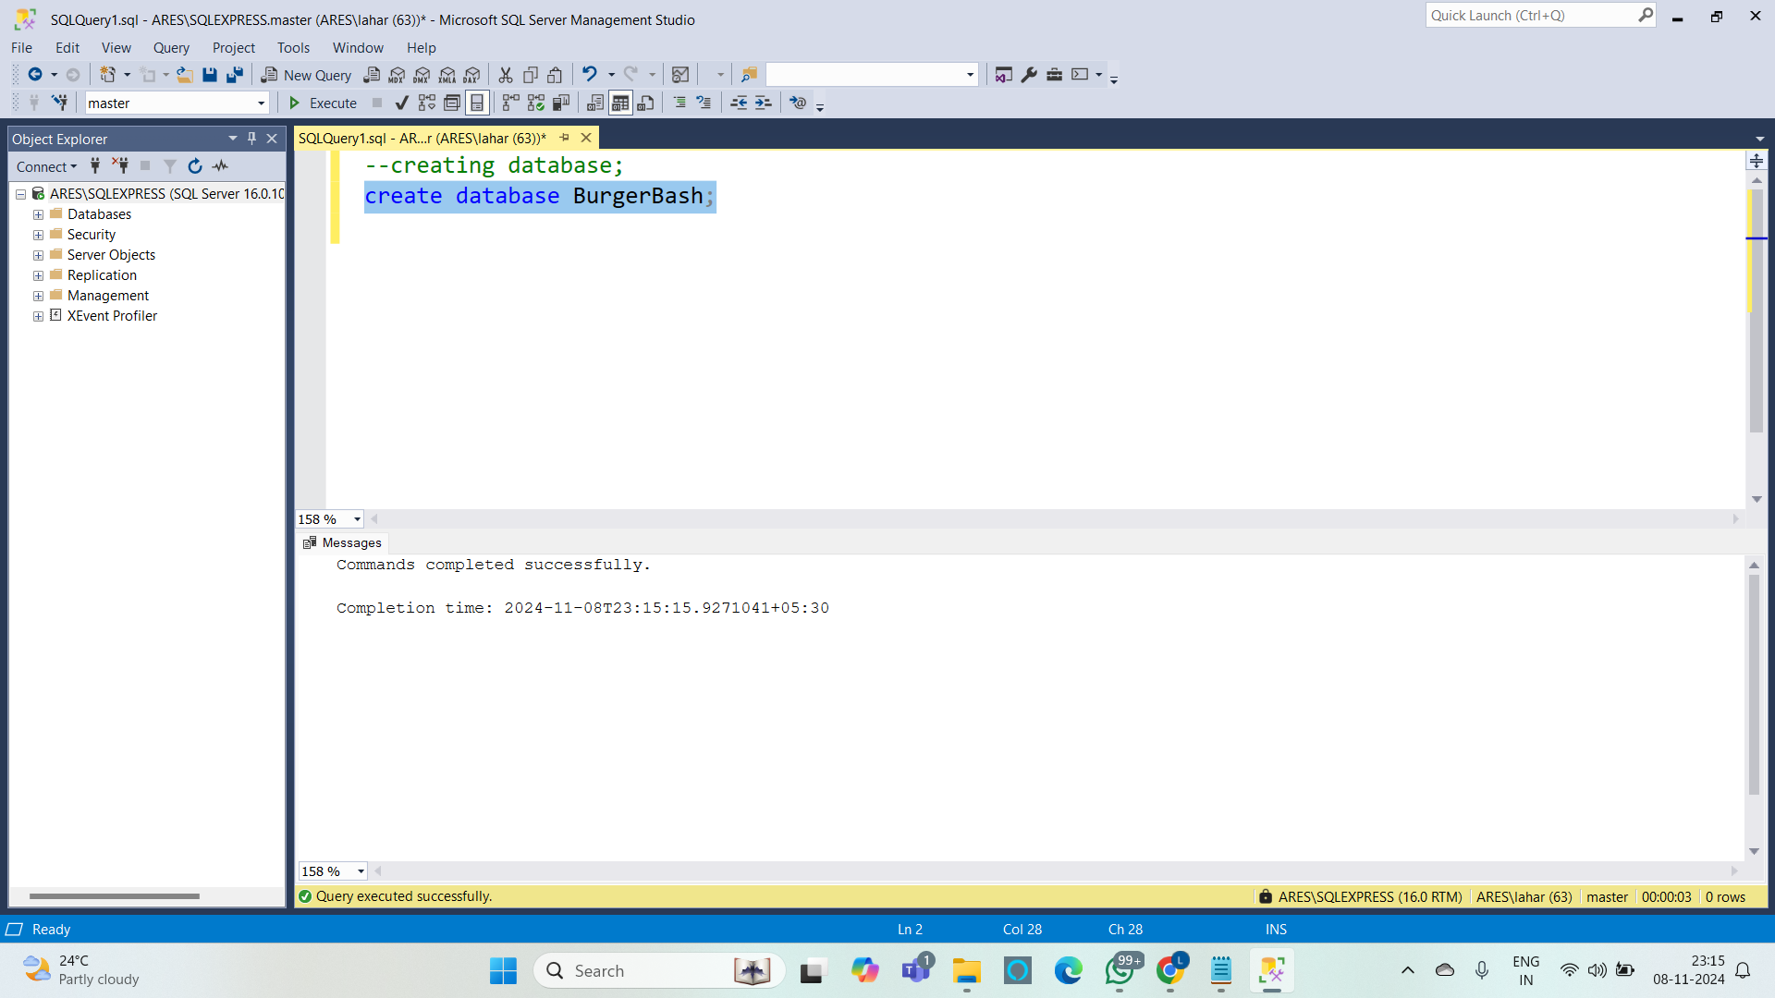

**Create table runner orders :**

**Query :**

CREATE TABLE runner_orders(

order_id INTEGER NOT NULL PRIMARY KEY

,runner_id INTEGER NOT NULL

,pickup_time DATETIME

,distance VARCHAR(7)

,duration VARCHAR(10)

,cancellation VARCHAR(23)

);

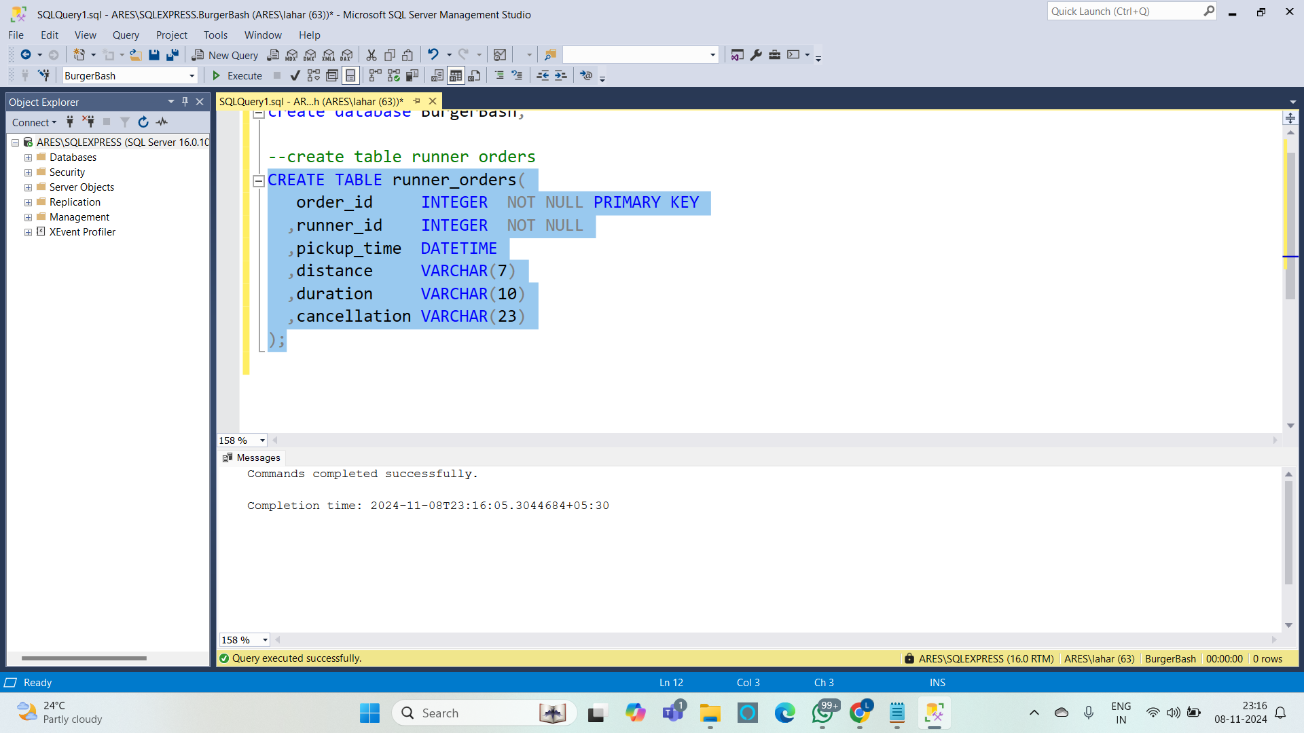

**Insert values into runner orders :**

**Query :**

INSERT INTO runner_orders VALUES (1,1,'2021-01-01 18:15:34','20km','32 minutes',NULL);

INSERT INTO runner_orders VALUES (2,1,'2021-01-01 19:10:54','20km','27 minutes',NULL);

INSERT INTO runner_orders VALUES (3,1,'2021-01-03 00:12:37','13.4km','20 mins',NULL);

INSERT INTO runner_orders VALUES (4,2,'2021-01-04 13:53:03','23.4','40',NULL);

INSERT INTO runner_orders VALUES (5,3,'2021-01-08 21:10:57','10','15',NULL);

INSERT INTO runner_orders VALUES (6,3,NULL,NULL,NULL,'Restaurant Cancellation');

INSERT INTO runner_orders VALUES (7,2,'2021-01-08 21:30:45','25km','25mins',NULL);

INSERT INTO runner_orders VALUES (8,2,'2021-01-10 00:15:02','23.4 km','15 minute',NULL);

INSERT INTO runner_orders VALUES (9,2,NULL,NULL,NULL,'Customer Cancellation');

INSERT INTO runner_orders VALUES (10,1,'2021-01-11 18:50:20','10km','10minutes',NULL);

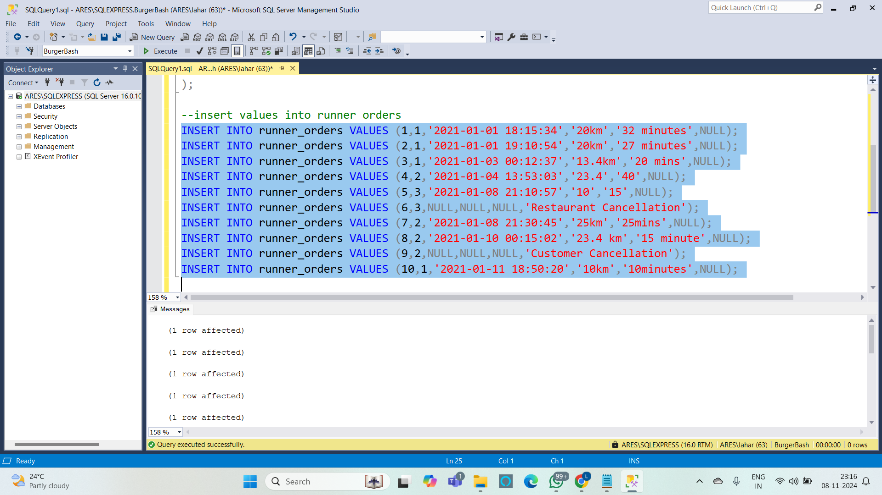

**Create customer order :**

**Query :**

CREATE TABLE customer_orders(

order_id INTEGER NOT NULL

,customer_id INTEGER NOT NULL

,burger_id INTEGER NOT NULL

,exclusions VARCHAR(4)

,extras VARCHAR(4)

,order_time DATETIME NOT NULL

);

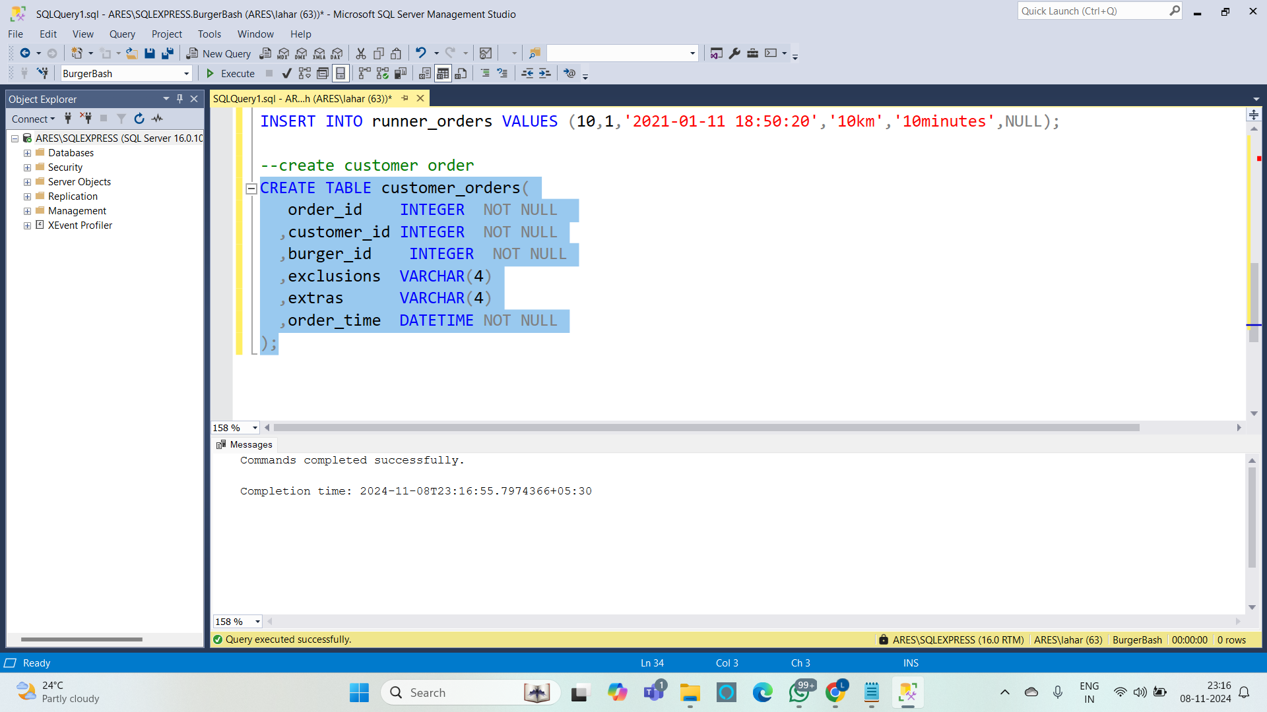

**Insert values into customer order :**

**Query :**

INSERT INTO customer_orders VALUES (1,101,1,NULL,NULL,'2021-01-01 18:05:02');

INSERT INTO customer_orders VALUES (2,101,1,NULL,NULL,'2021-01-01 19:00:52');

INSERT INTO customer_orders VALUES (3,102,1,NULL,NULL,'2021-01-02 23:51:23');

INSERT INTO customer_orders VALUES (3,102,2,NULL,NULL,'2021-01-02 23:51:23');

INSERT INTO customer_orders VALUES (4,103,1,'4',NULL,'2021-01-04 13:23:46');

INSERT INTO customer_orders VALUES (4,103,1,'4',NULL,'2021-01-04 13:23:46');

INSERT INTO customer_orders VALUES (4,103,2,'4',NULL,'2021-01-04 13:23:46');

INSERT INTO customer_orders VALUES (5,104,1,NULL,'1','2021-01-08 21:00:29');

INSERT INTO customer_orders VALUES (6,101,2,NULL,NULL,'2021-01-08 21:03:13');

INSERT INTO customer_orders VALUES (7,105,2,NULL,'1','2021-01-08 21:20:29');

INSERT INTO customer_orders VALUES (8,102,1,NULL,NULL,'2021-01-09 23:54:33');

INSERT INTO customer_orders VALUES (9,103,1,'4','1, 5','2021-01-10 11:22:59');

INSERT INTO customer_orders VALUES (10,104,1,NULL,NULL,'2021-01-11 18:34:49');

INSERT INTO customer_orders VALUES (10,104,1,'2, 6','1, 4','2021-01-11 18:34:49');

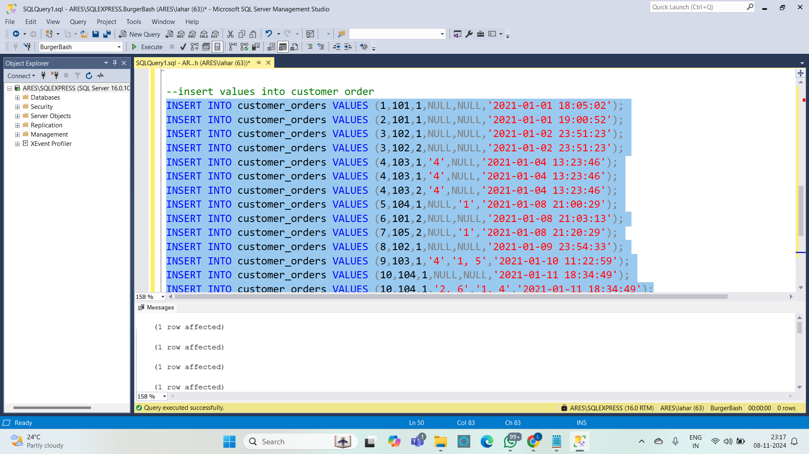

**Create burger table :**

**Query :**

CREATE TABLE burger_names(

burger_id INTEGER NOT NULL PRIMARY KEY

,burger_name VARCHAR(10) NOT NULL

);

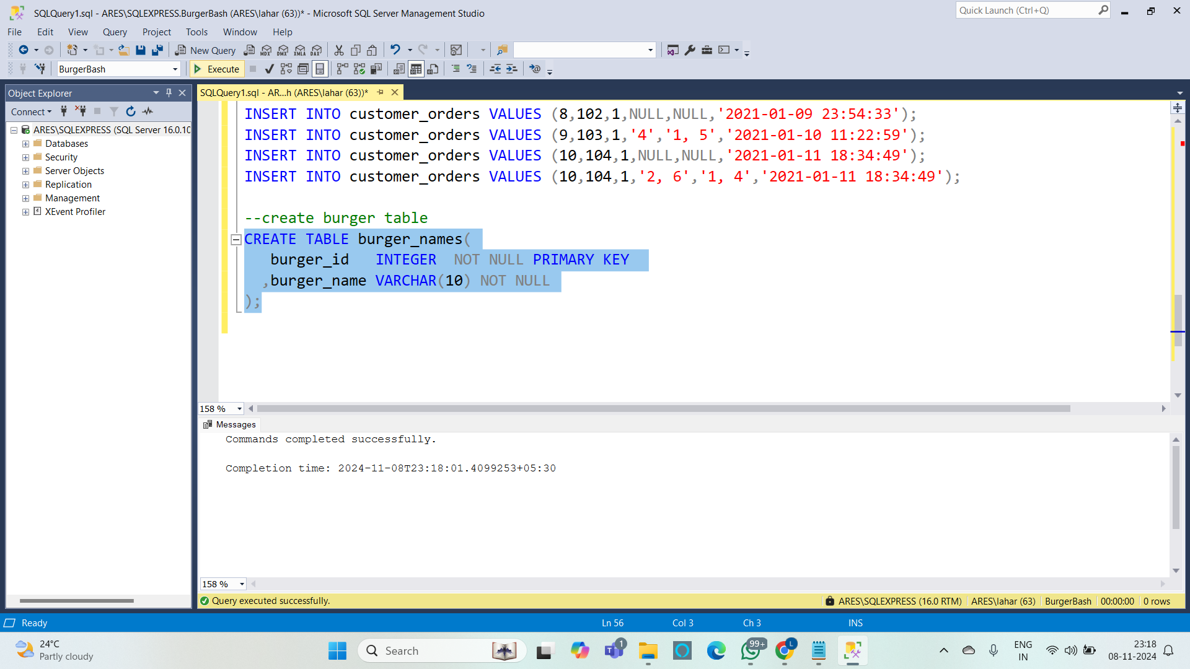

**Insert values into burger table :**

**Query :**

INSERT INTO burger_names(burger_id,burger_name) VALUES (1,'Meatlovers');

INSERT INTO burger_names(burger_id,burger_name) VALUES (2,'Vegetarian');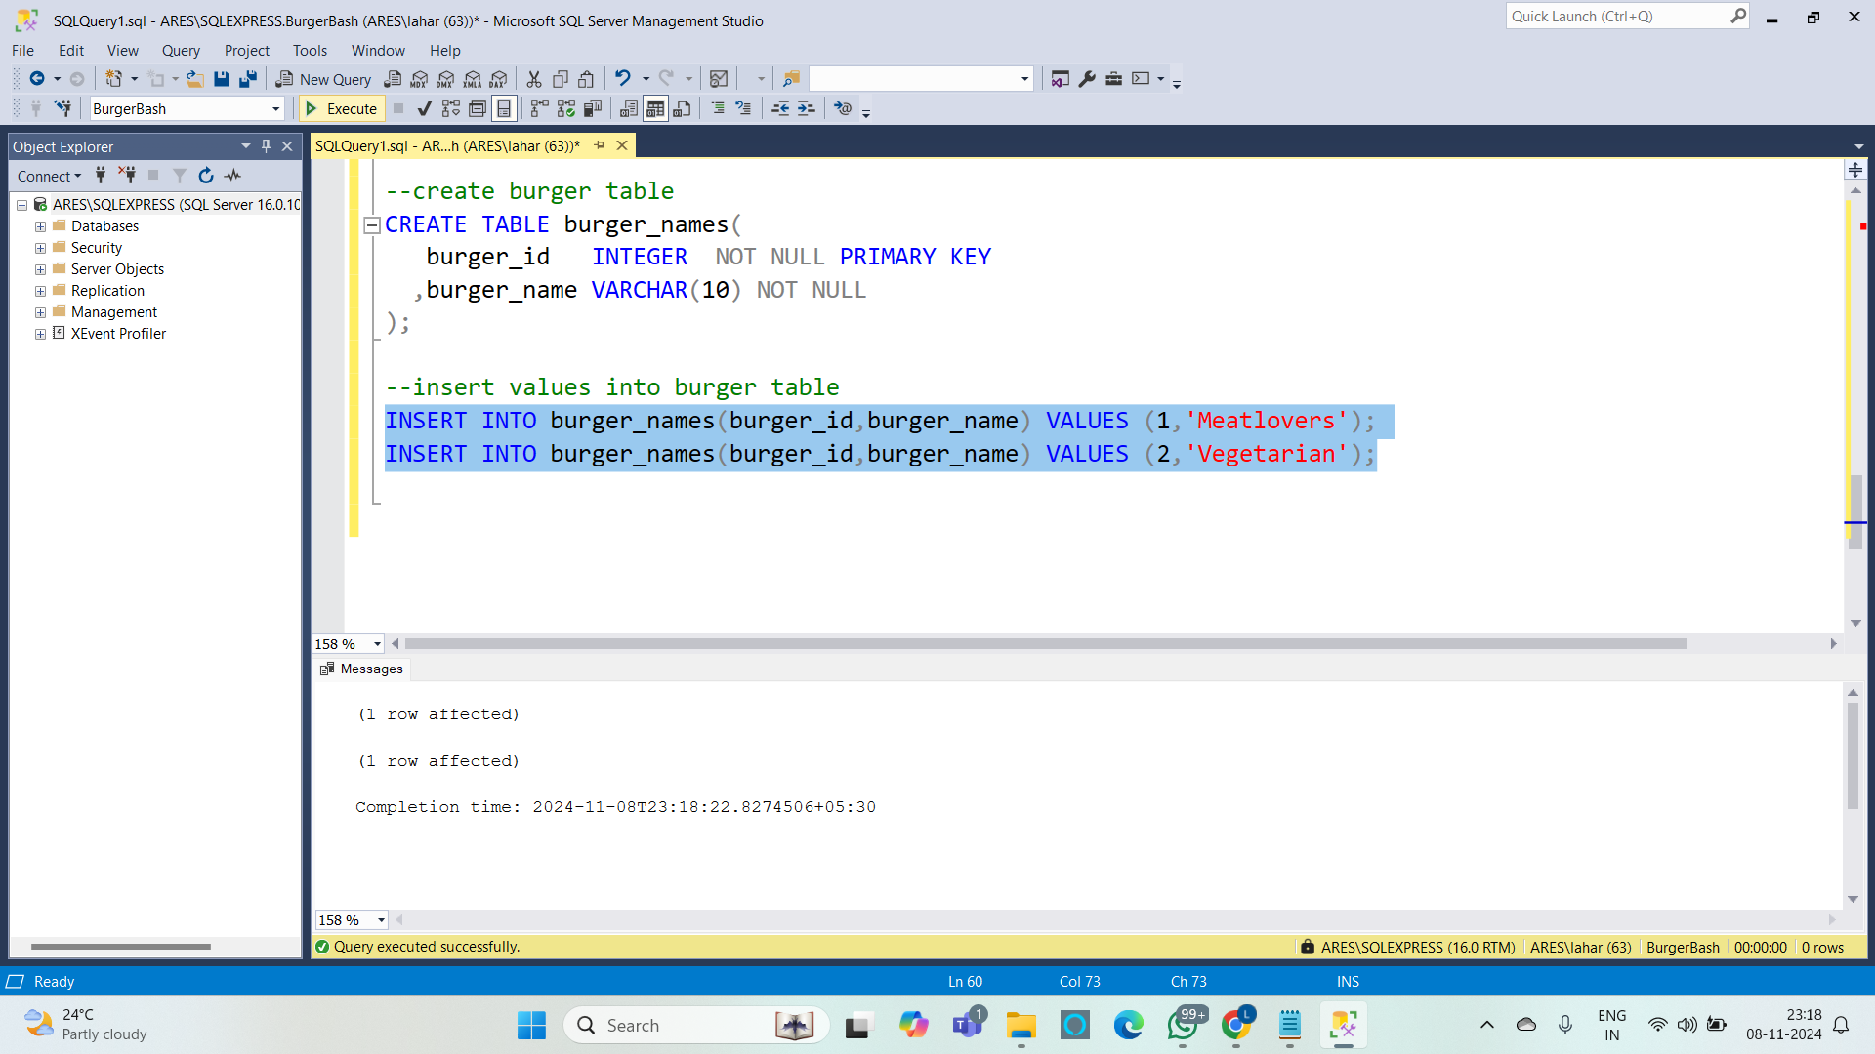

**Create burger runner :**

**Query :**

CREATE TABLE burger_runner(

runner_id INTEGER NOT NULL PRIMARY KEY

,registration_date date NOT NULL

);

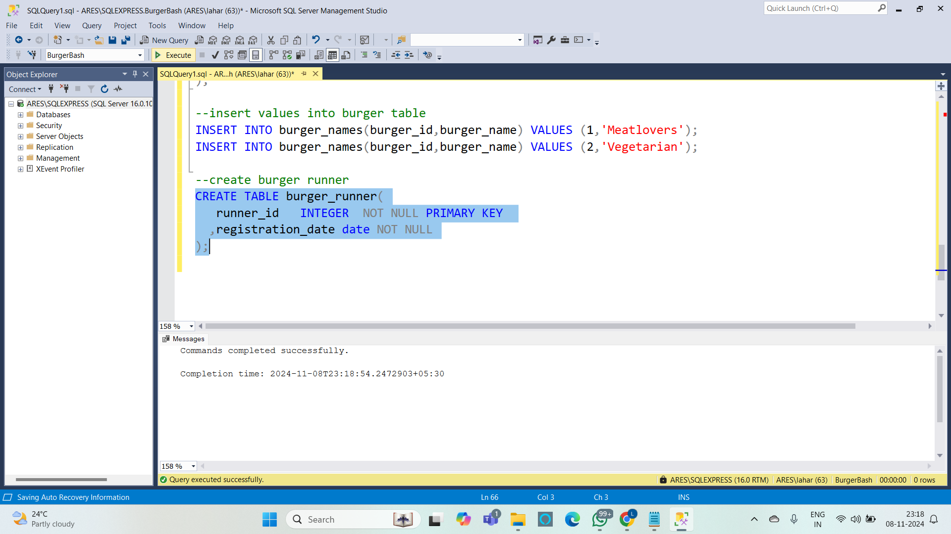

**Insert values into burger runner :**

**Query :**

INSERT INTO burger_runner VALUES (1,'2021-01-01');

INSERT INTO burger_runner VALUES (2,'2021-01-03');

INSERT INTO burger_runner VALUES (3,'2021-01-08');

INSERT INTO burger_runner VALUES (4,'2021-01-15');

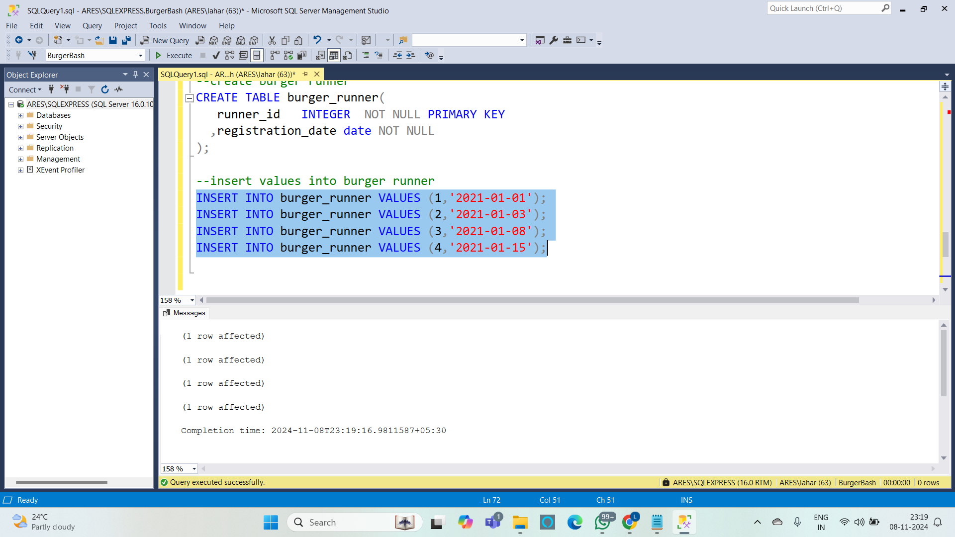

**Representing tables :**

**Query :**

select * from runner_orders;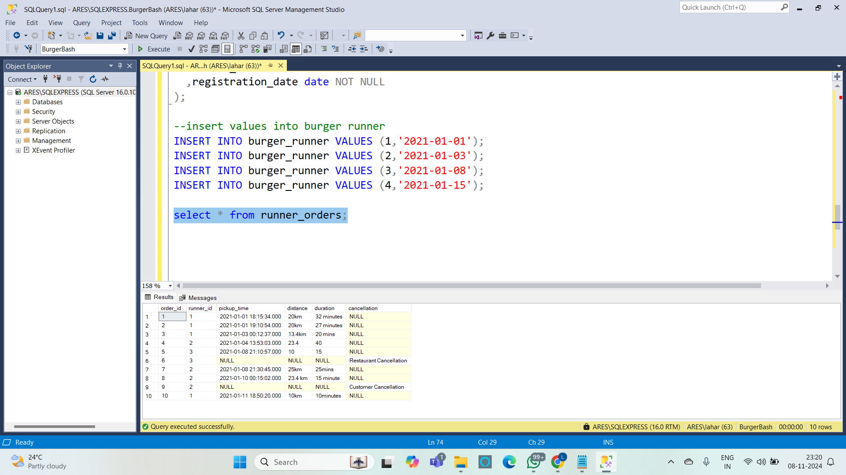

select * from customer_orders;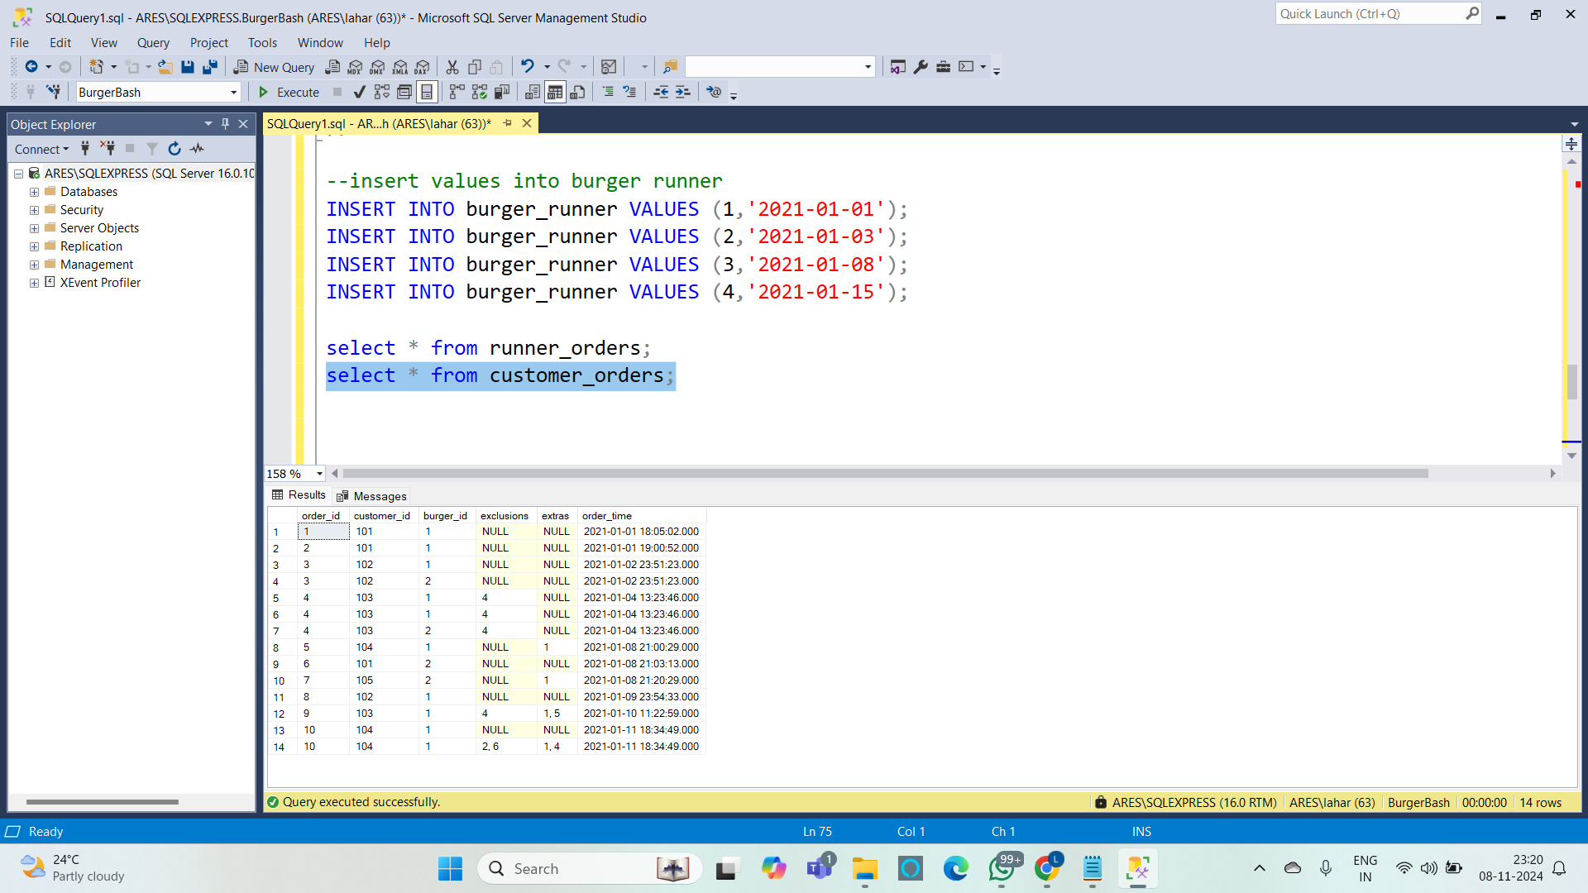

select * from burger_names;

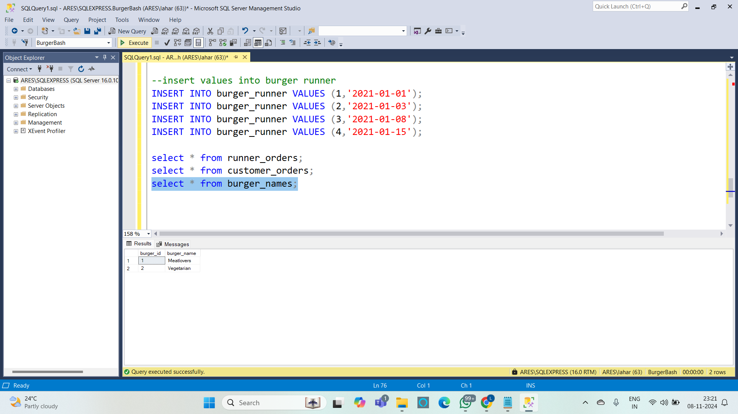

select * from burger_runner;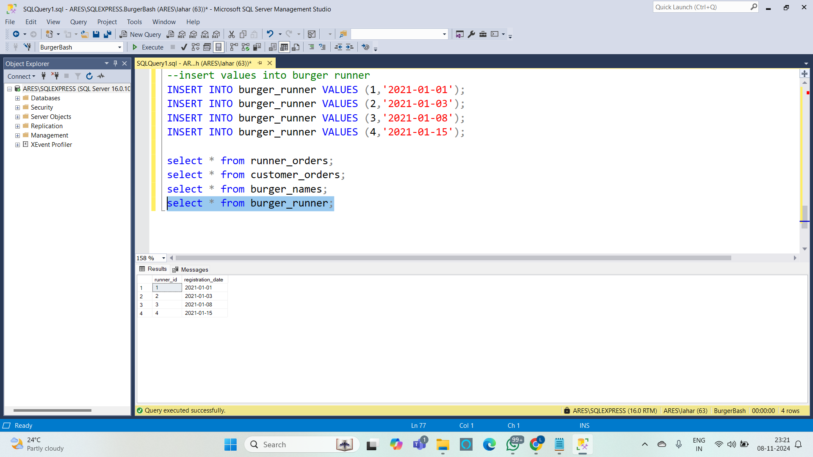

**Queries :**

**1. How many burgers were ordered?**

**Query :** SELECT COUNT(*) AS total_burgers_ordered FROM customer_orders;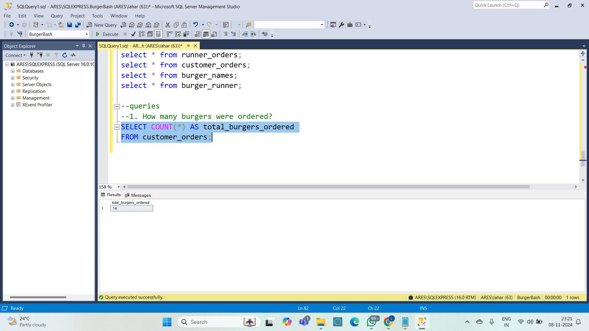

**2. How many unique customer orders were made?**

**Query :**

SELECT COUNT(DISTINCT order_id) AS unique_customer_orders

FROM customer_orders;

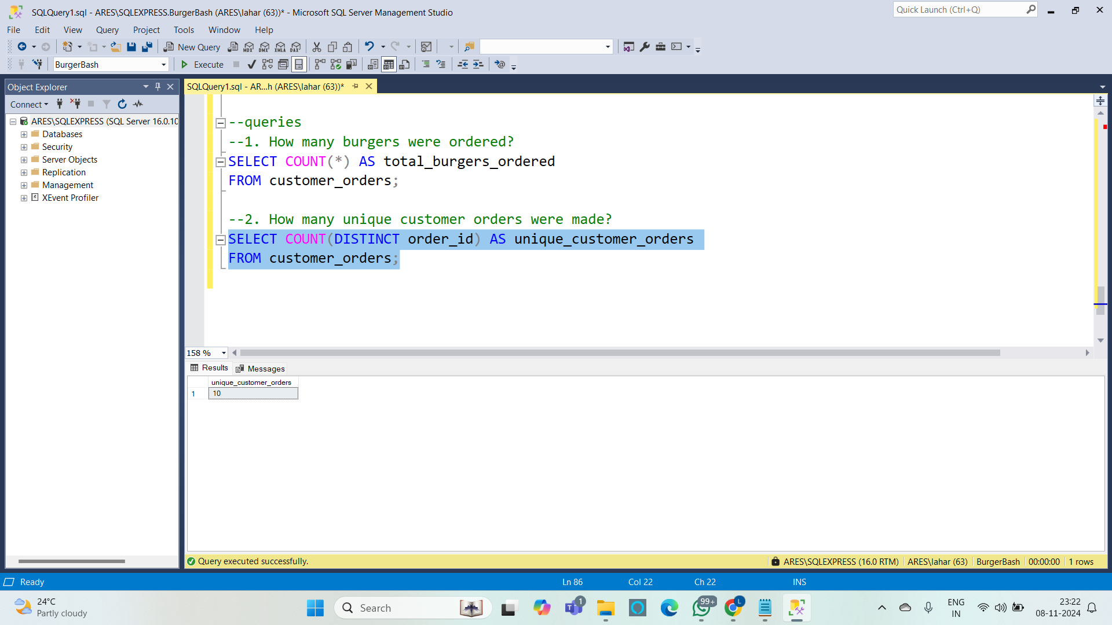

**3. How many successful orders were delivered by each runner?**

**Query :**

SELECT runner_id, COUNT(order_id) AS successful_orders

FROM runner_orders

WHERE cancellation IS NULL

GROUP BY runner_id;

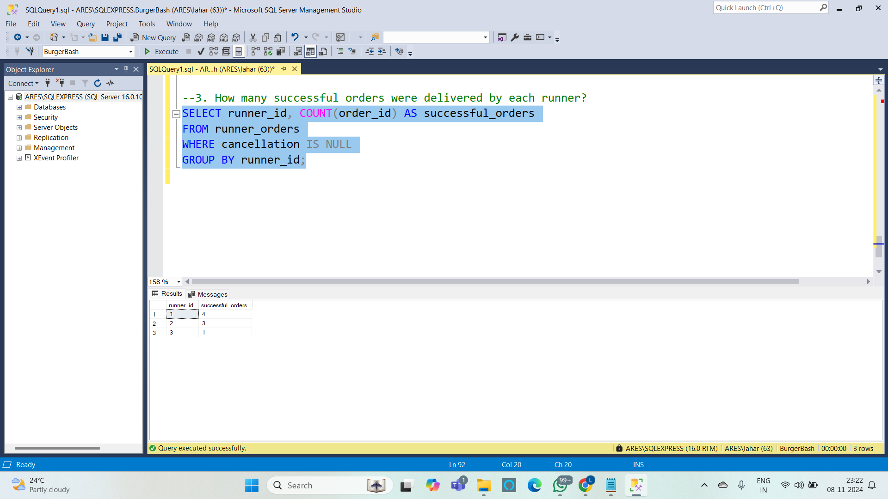

**4. How many of each type of burger was delivered?**

**Query :**

SELECT runner_id, COUNT(order_id) AS successful_orders

FROM runner_orders

WHERE cancellation IS NULL

GROUP BY runner_id;

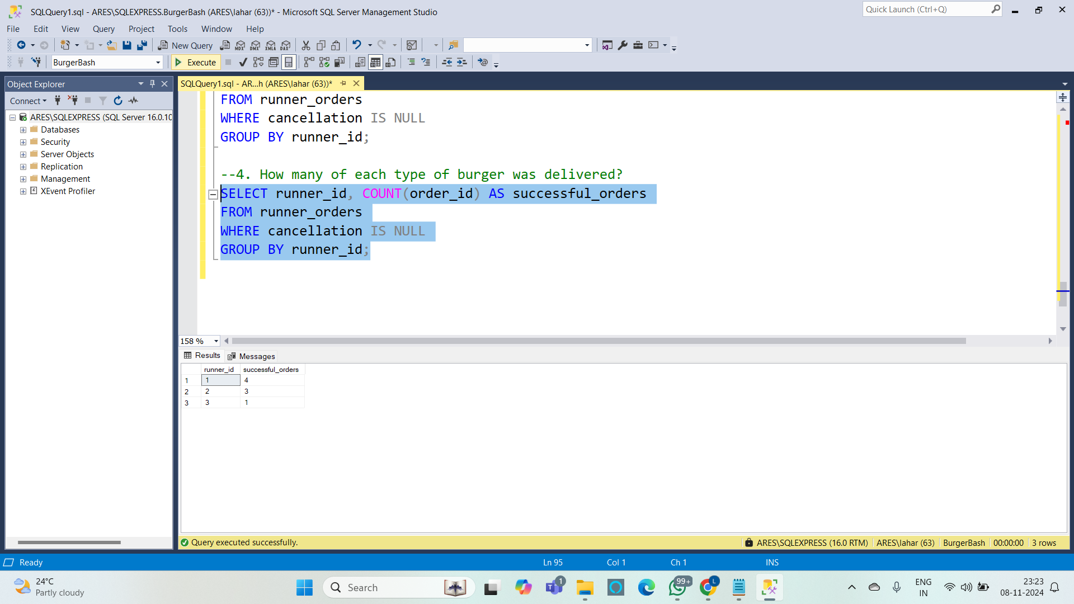

**5. How many Vegetarian and Meatlovers were ordered by each customer?**

**Query :**

SELECT customer_id, burger_name, COUNT(*) AS burger_count

FROM customer_orders

JOIN burger_names ON customer_orders.burger_id = burger_names.burger_id

GROUP BY customer_id, burger_name

ORDER BY customer_id, burger_name;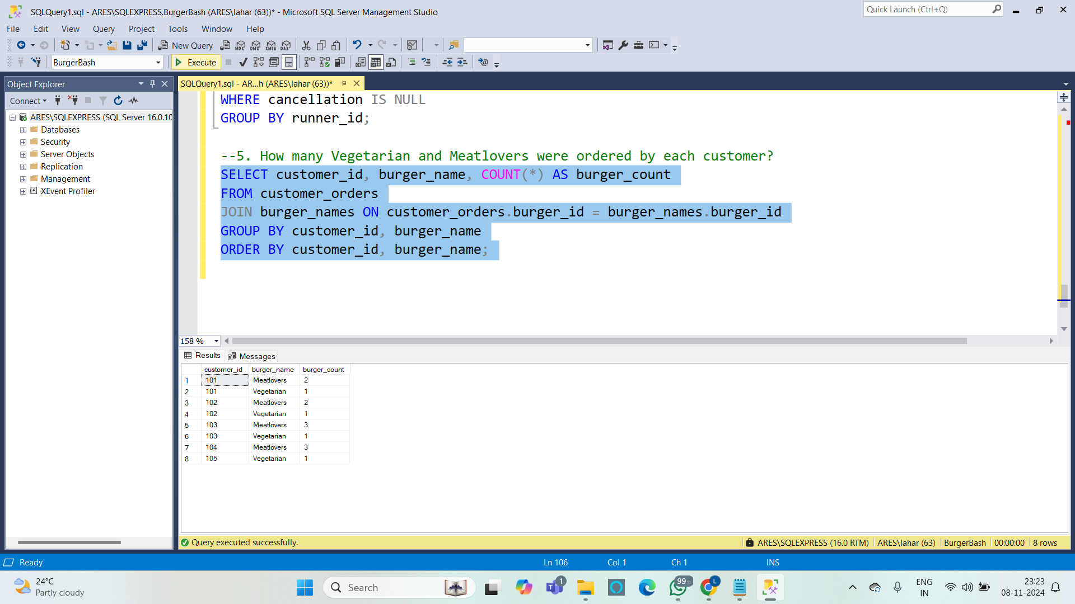

**6. What was the maximum number of burgers delivered in a single order?**

**Query :**

SELECT order_id, COUNT(*) AS burger_count

FROM customer_orders

GROUP BY order_id

ORDER BY burger_count DESC;

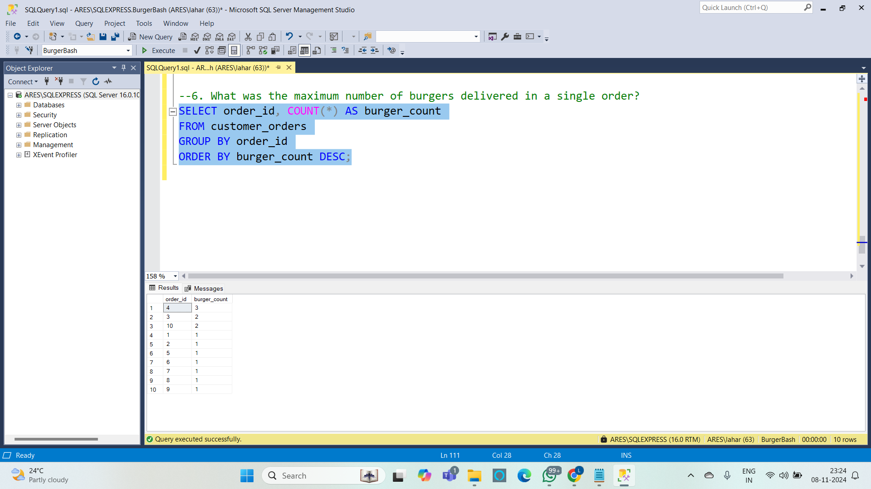

**7. For each customer, how many delivered burgers had at least 1 change and how many had no changes?**

**Query :**

SELECT

customer_orders.customer_id,

SUM(CASE WHEN (exclusions IS NOT NULL OR extras IS NOT NULL) THEN 1 ELSE 0 END)

AS burgers_with_changes,

SUM(CASE WHEN (exclusions IS NULL AND extras IS NULL) THEN 1 ELSE 0 END)

AS burgers_without_changes

FROM customer_orders

JOIN runner_orders ON customer_orders.order_id = runner_orders.order_id

WHERE runner_orders.cancellation IS NULL

GROUP BY customer_orders.customer_id

ORDER BY customer_orders.customer_id;

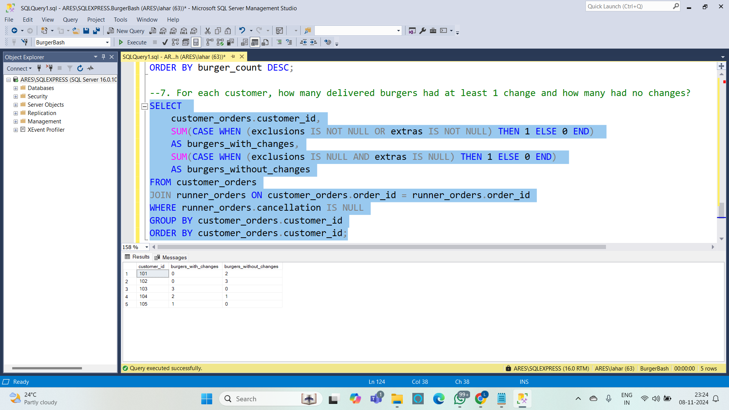

**8. What was the total volume of burgers ordered for each hour of the day?**

**Query :**

SELECT

DATEPART(HOUR, order_time) AS order_hour,

COUNT(*) AS total_burgers_ordered

FROM customer_orders

GROUP BY DATEPART(HOUR, order_time)

ORDER BY order_hour;

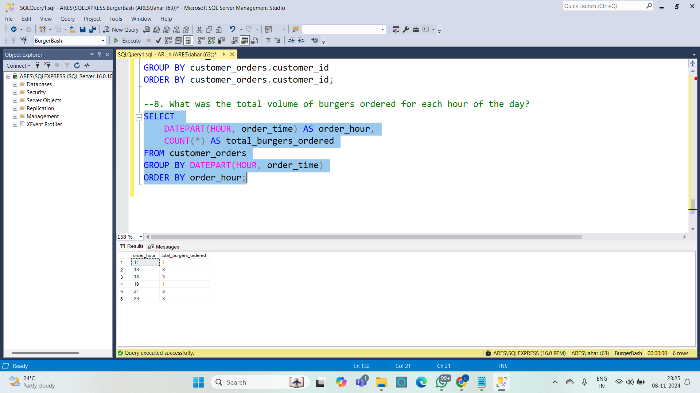

**9. How many runners signed up for each 1 week period?**

SELECT

DATEPART(YEAR, registration_date) AS signup_year,

DATEPART(WEEK, registration_date) AS signup_week,

COUNT(*) AS runners_signed_up

FROM burger_runner

GROUP BY DATEPART(YEAR, registration_date), DATEPART(WEEK, registration_date)

ORDER BY signup_year, signup_week;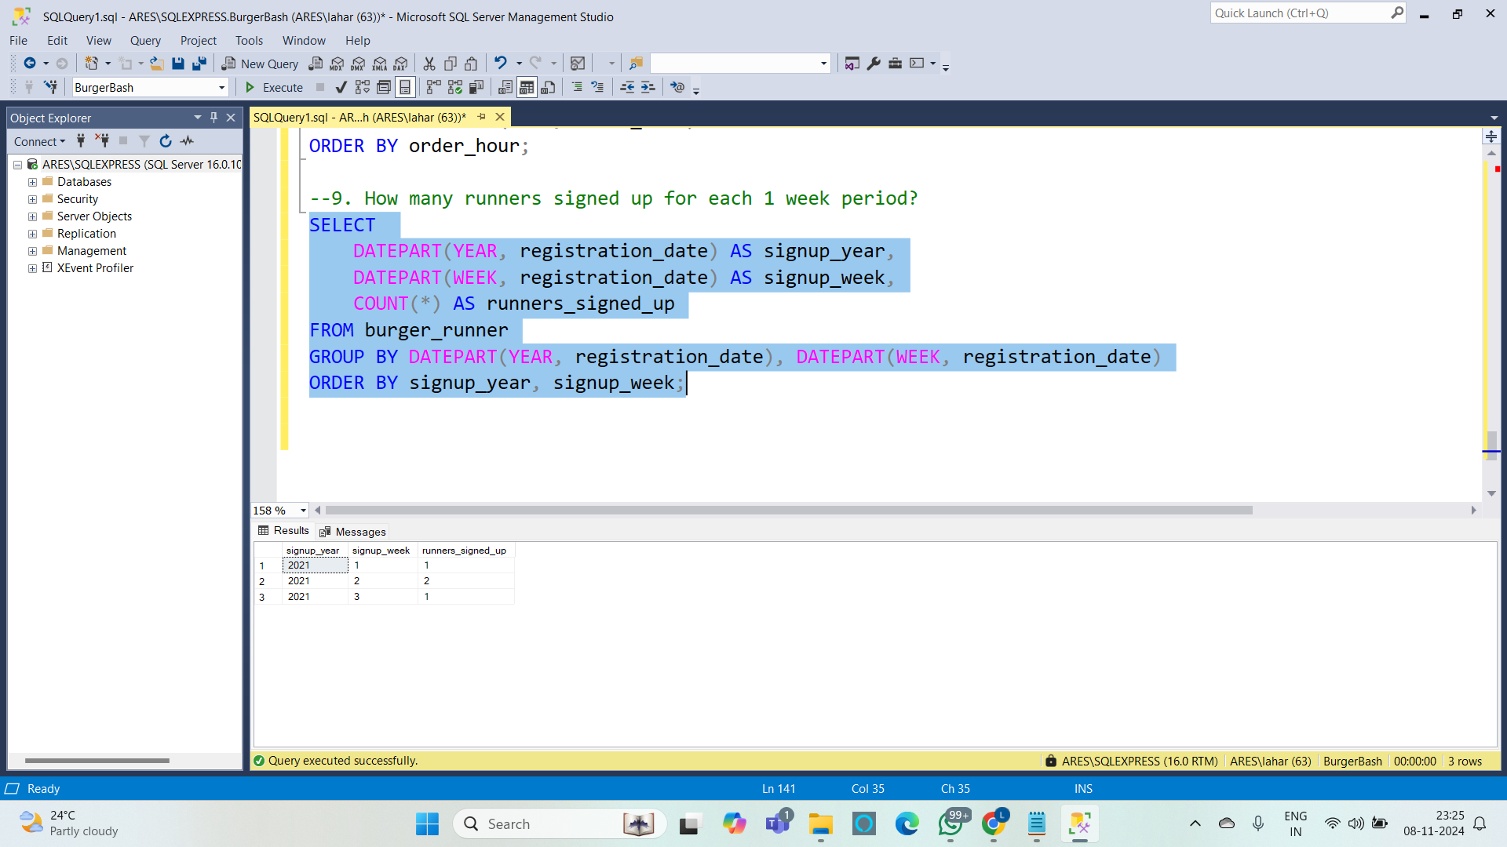

**10. What was the average distance travelled for each customer?**

**Query :**

SELECT

customer_orders.customer_id,

AVG(CAST(REPLACE(runner_orders.distance, 'km', '') AS FLOAT)) AS avg_distance_travelled

FROM customer_orders

JOIN runner_orders ON customer_orders.order_id = runner_orders.order_id

WHERE runner_orders.cancellation IS NULL

GROUP BY customer_orders.customer_id

ORDER BY customer_orders.customer_id;

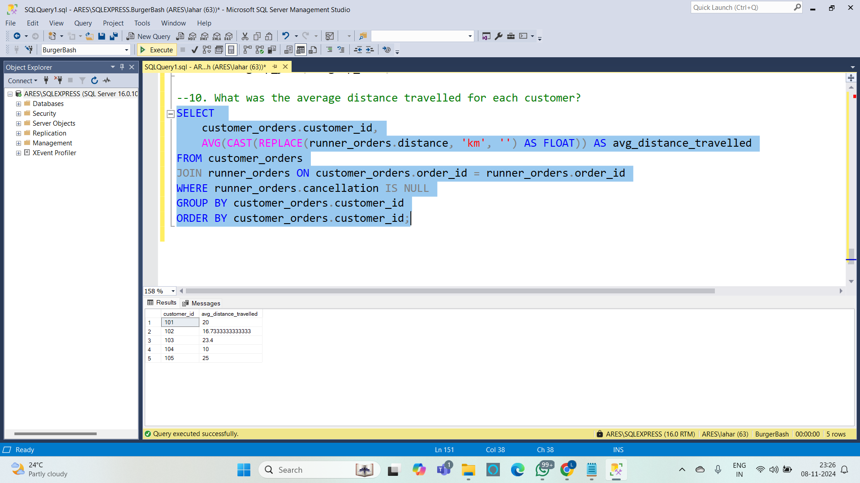

**Subqueries**

**1. Find the customer who ordered the most burgers (GROUP BY, HAVING)**

**Query :**

SELECT customer_id, COUNT(*) AS total_burgers_ordered

FROM customer_orders

GROUP BY customer_id

HAVING COUNT(*) = (

SELECT MAX(burger_count)

FROM (

SELECT customer_id, COUNT(*) AS burger_count

FROM customer_orders

GROUP BY customer_id

) AS subquery

);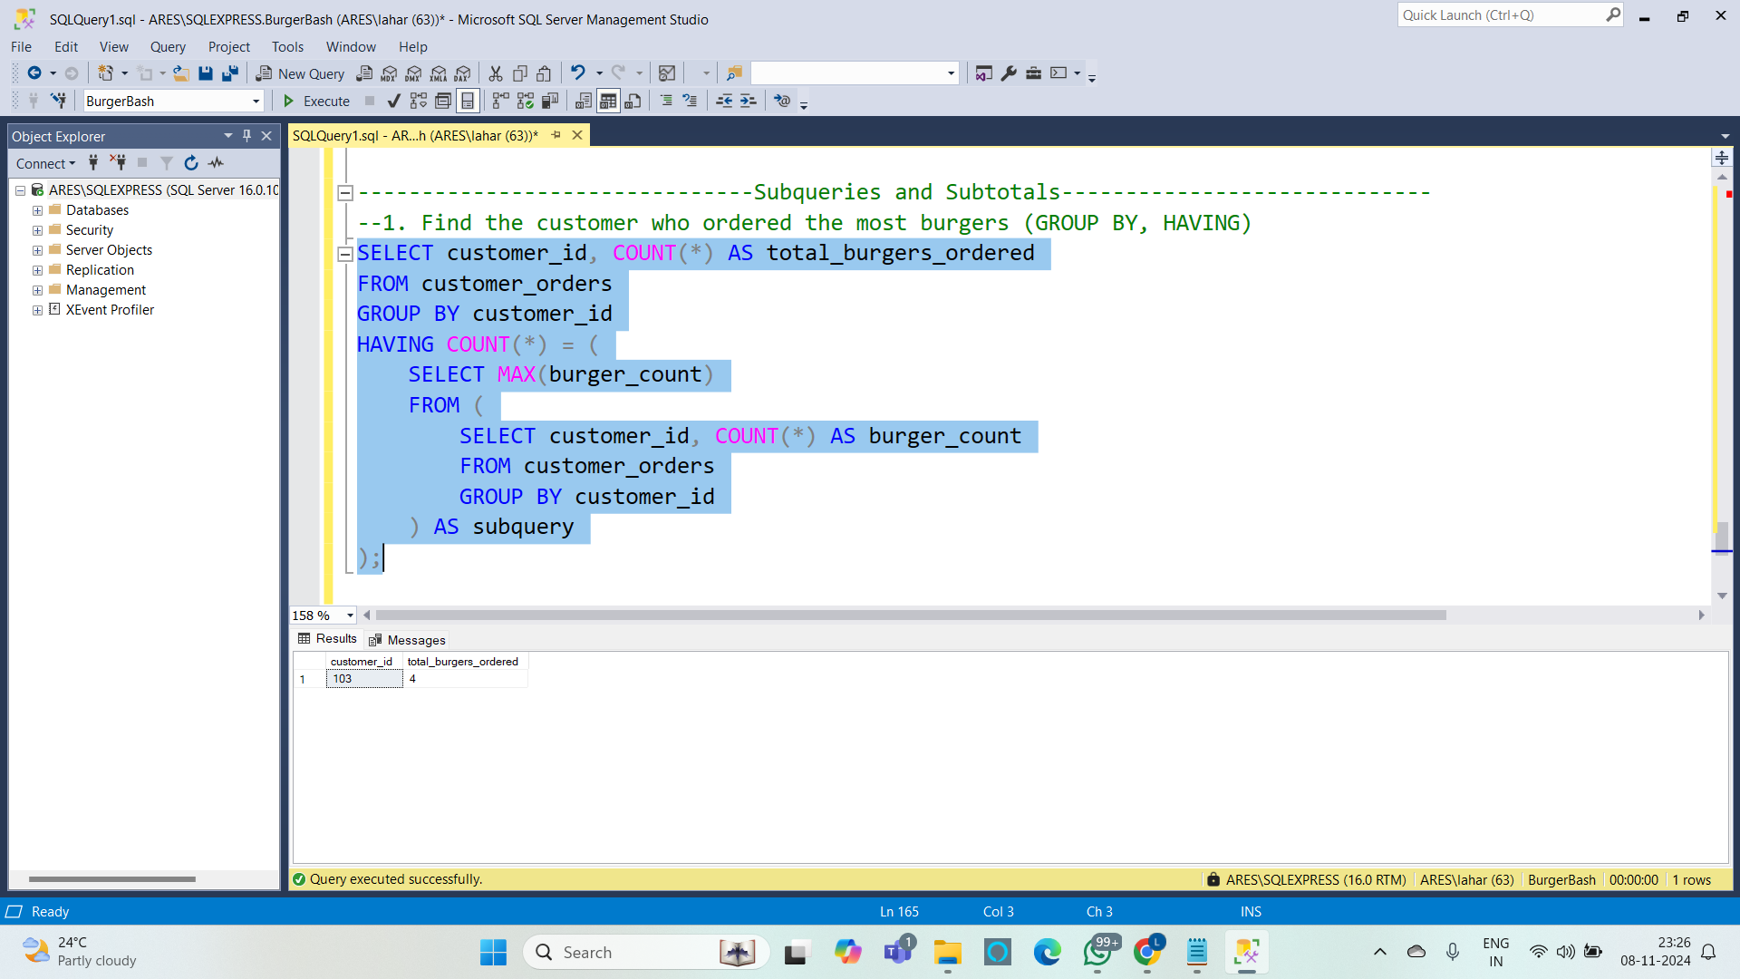

**2. Find the total number of cancellations (by customer or restaurant) for each runner (Subqueries)**

**Query :**

SELECT runner_id,

(SELECT COUNT(*)

FROM runner_orders

WHERE runner_orders.runner_id = burger_runner.runner_id AND cancellation IS NOT NULL)

AS total_cancellations

FROM burger_runner;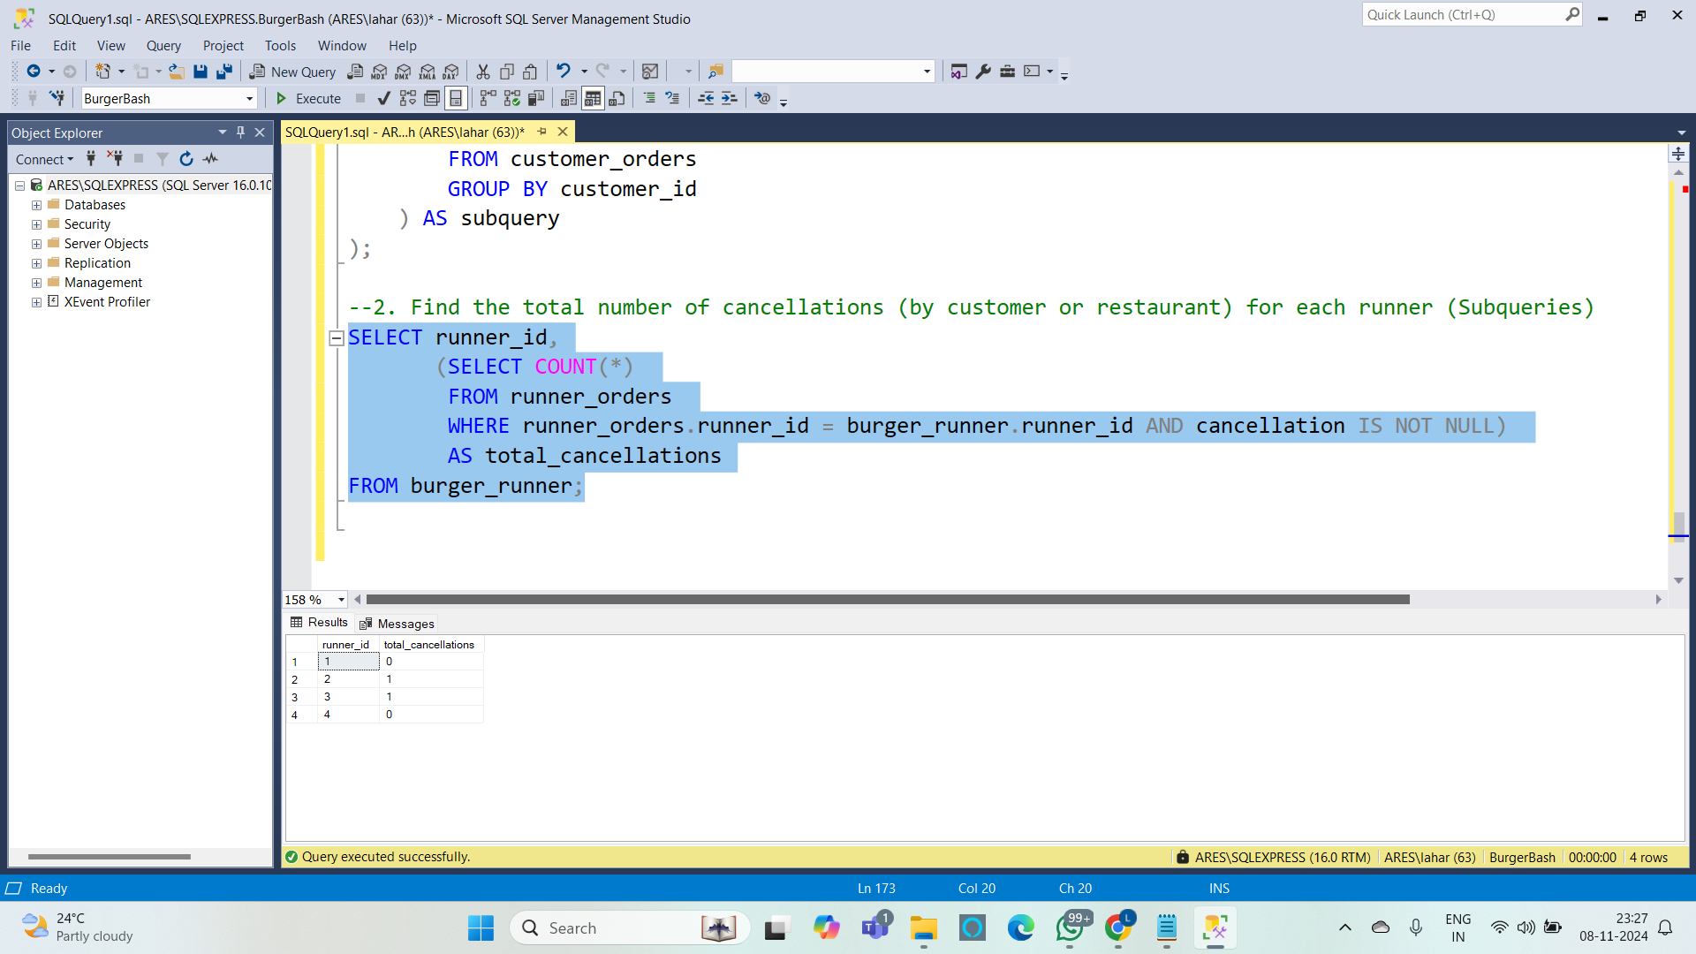

**3. Find the average distance for each burger type ordered (Meatlovers vs. Vegetarian)**

**Query :**

SELECT burger_name,

AVG(CAST(REPLACE(runner_orders.distance, 'km', '') AS FLOAT)) AS avg_distance

FROM customer_orders

JOIN burger_names ON customer_orders.burger_id = burger_names.burger_id

JOIN runner_orders ON customer_orders.order_id = runner_orders.order_id

WHERE runner_orders.cancellation IS NULL

GROUP BY burger_name;

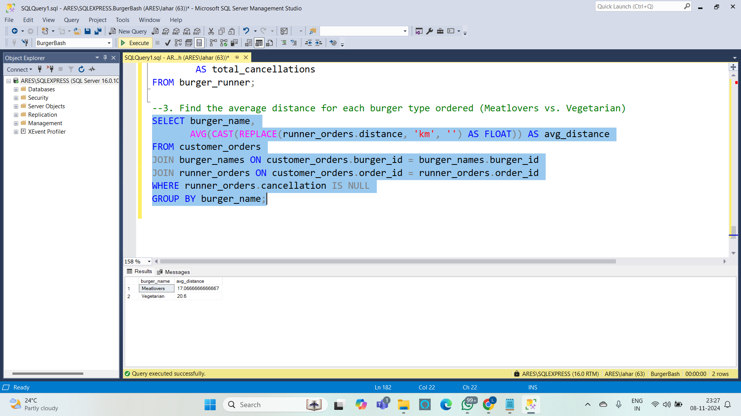

**4. List the customers who have ordered the most burgers in a single day.**

**Query :**

SELECT customer_id, order_date, MAX(burger_count) AS max_burgers_ordered

FROM (

SELECT customer_id, CAST(order_time AS DATE) AS order_date, COUNT(*) AS burger_count

FROM customer_orders

GROUP BY customer_id, CAST(order_time AS DATE)

) AS subquery

GROUP BY customer_id, order_date;

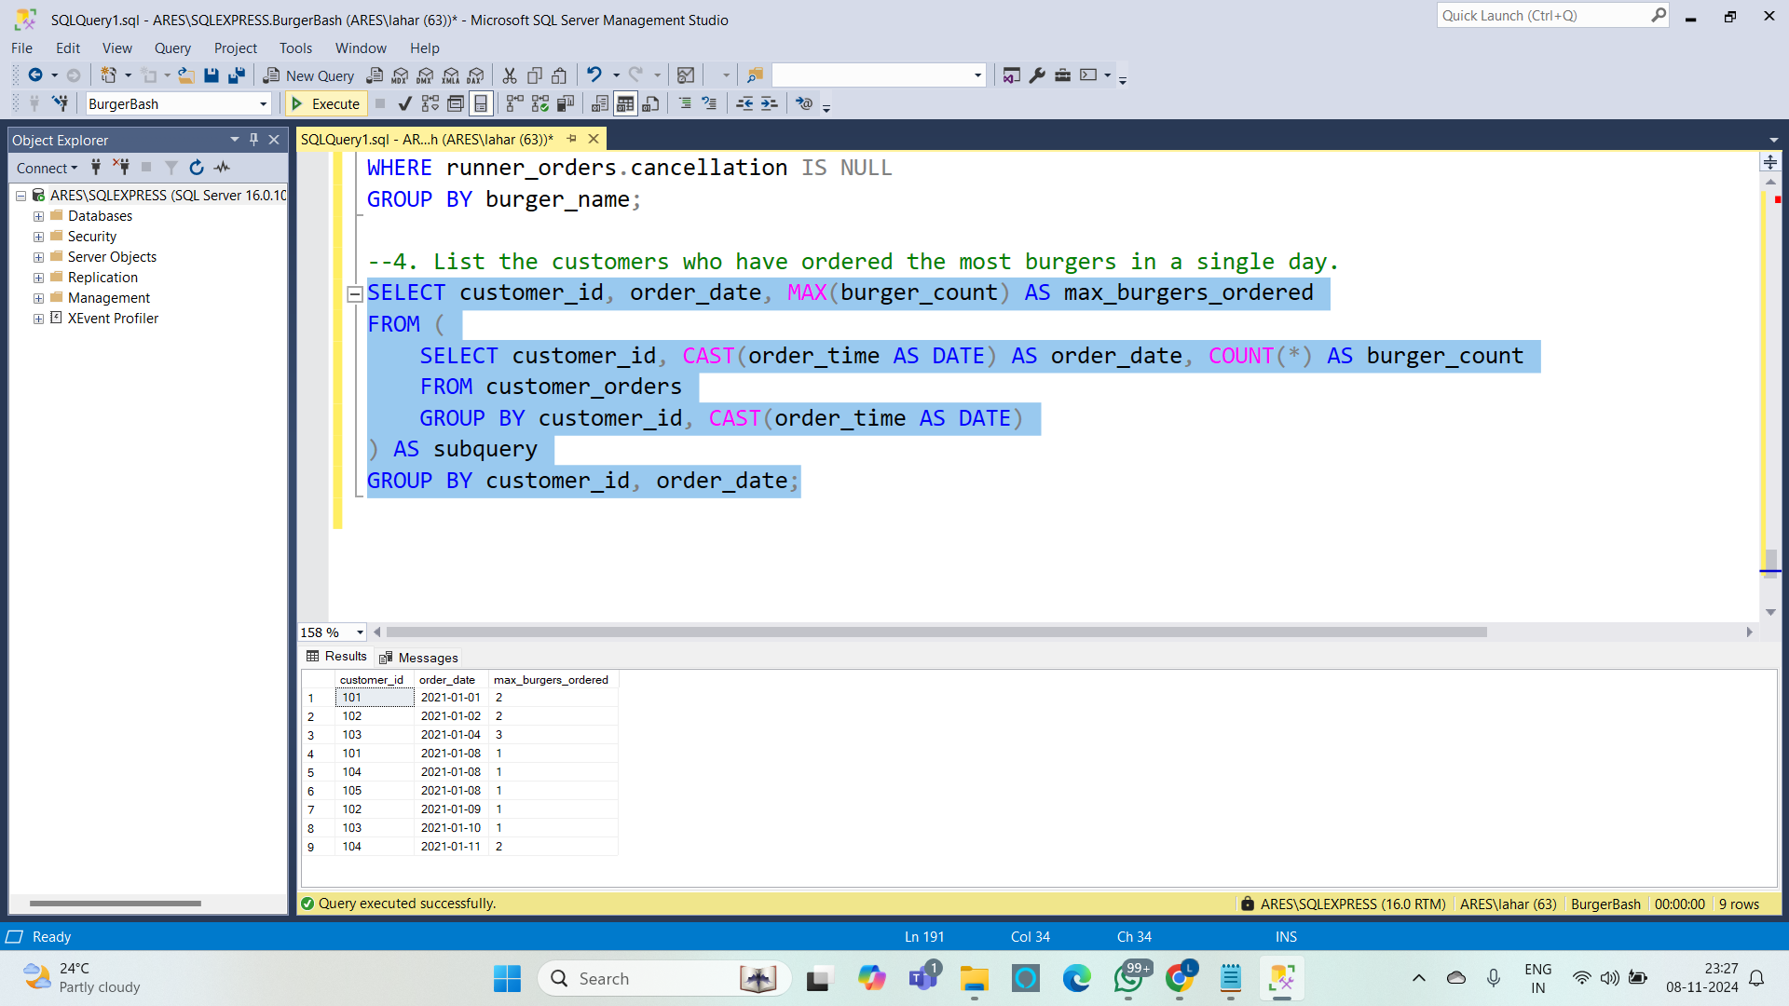

**5. Find the total number of orders and burgers ordered for each runner**

**Query :**

SELECT runner_id,

(SELECT COUNT(*) FROM runner_orders WHERE runner_orders.runner_id = burger_runner.runner_id)

AS total_orders,

(SELECT COUNT(*) FROM customer_orders WHERE customer_orders.order_id

IN (SELECT order_id FROM runner_orders WHERE runner_orders.runner_id = burger_runner.runner_id))

AS total_burgers_ordered

FROM burger_runner;

